Errata – 5th edition (1/9/2019)

* Page 200, Example 7.13, - this error and the next one for Example 7.14 were caused by the correction of Equation (7.10) in the 5th edition – previously the equation was written incorrectly for *P* in barg

part (c)

$$F_{p,vessels}=\frac{\frac{(20)(3)}{\left(2\right)\left(944\right)\left(0.9\right)-1.2(20)}+0.00315}{0.0063}=6.185$$

FM = 3.11

$$F_{BM}=2.25+1.82\left(6.185\right)\left(3.11\right)=37.26$$

Part (d)

$$C_{BM}\left(2016\right)=\left(180,890\right)\left(37.26\right)=\$6,739,700$$

Tray calculation is unchanged

$$C_{BM, tower+trays}\left(2016\right)=\$6,739,700+\$456,770=\$7,196,400$$

* Page 202-203, Example 7.14 – same error as in Example 7.13. The changes in Table E7.14(b) are

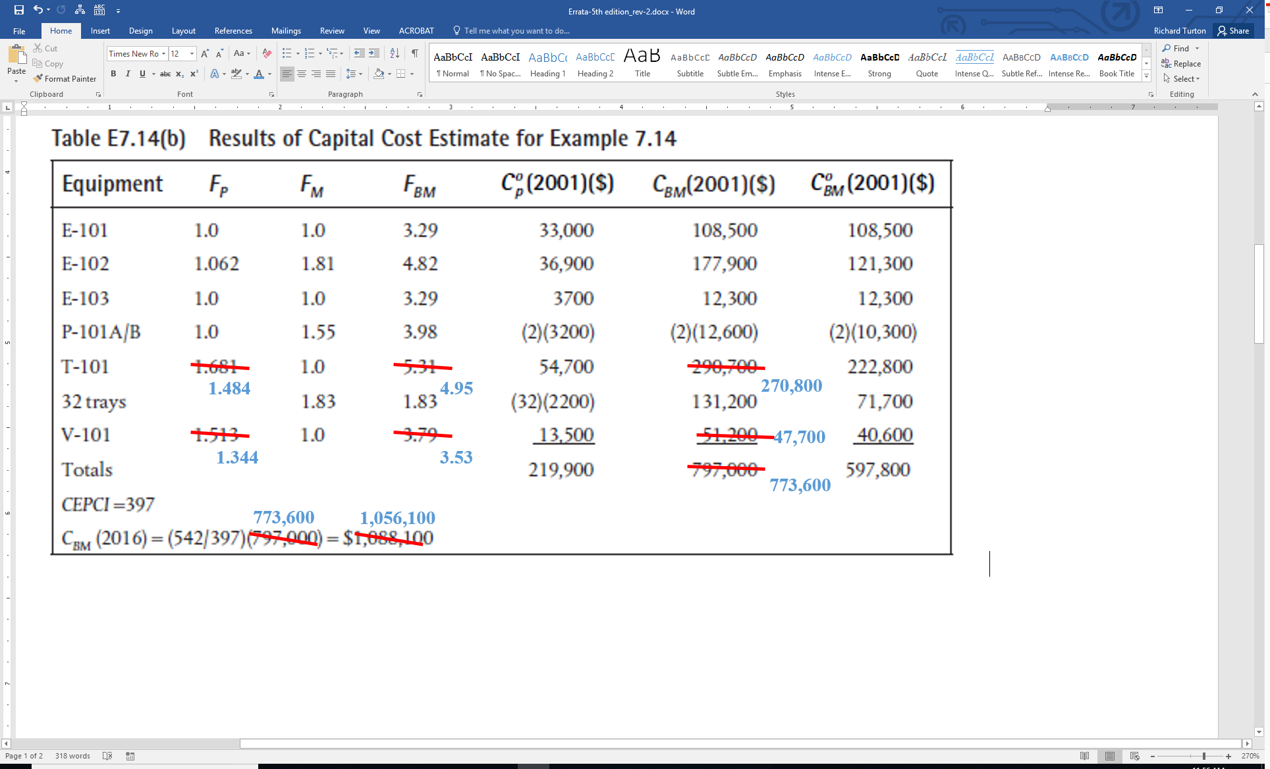

* For Capcost, the macro for vessels must be changed. The updated version of Capcost (rev2) is now uploaded to the website, the following table was generated using the updated Capcost_rev2. Note that there are a couple of other minor discrepancies in Table 7.12 that need to be updated in the book.

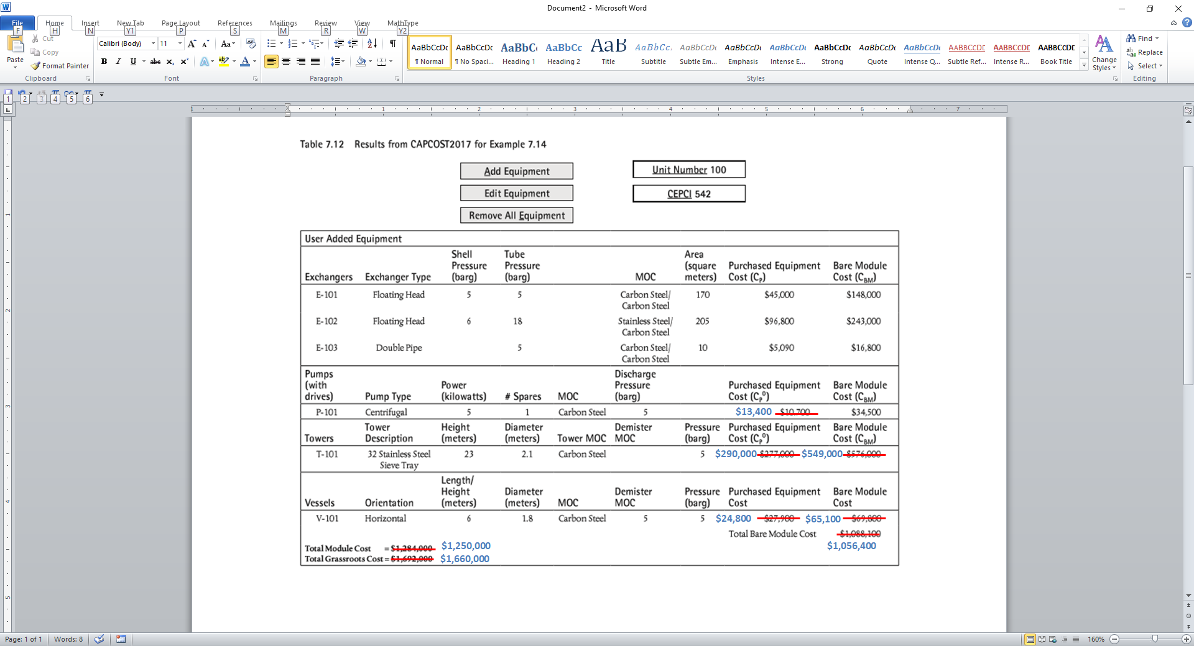

* Page 709, second to last line on the page, should read “pipe roughness factor, *e* is a length that represents”
* Page 750 – replace Equation 19.74 with



* Page 751 – replace Equation 19.78 with



* Page 982, replace Equation (22.42) with



* Page 993, 3rd paragraph from bottom of page, the units for k should read mol/s/bar2/kg (catalyst)
* Page 994, the final form in Equation E22.9a should read



* Page 1060, Problem 24 – the vapor mass fraction, *x* = 0.80 (**NOT** 0.45)
* Page 1292, Equation B.3.4 for the equilibrium constant for the styrene reaction should read $K=15.75-\frac{14,852.6}{T[K]}$
* Page 1293, Figure B.3.1 – note that for the sake of simplicity the flash vessel (V-401) is modelled as a component separator. In reality, some of the water and EB/styrene end up in the vapor (Stream 14). These can be separated if an aftercooler and flash vessel are added after C-401 and the condensed stream is sent to T-401.
* Page 1299, Equation B.3.6 for styrene production – the pre-exponential factor should read 1.177×108 **NOT** 10.177×1011
* Page 1299, Equation B.3.7 for styrene production – the pre-exponential factor should read 17.0 **NOT** 20.965
* Page 1305, Equation B.5.4 – the correct stoichiometry for the reaction is



* Page 1312, Figure B.6.1 should be replaced with the following figure

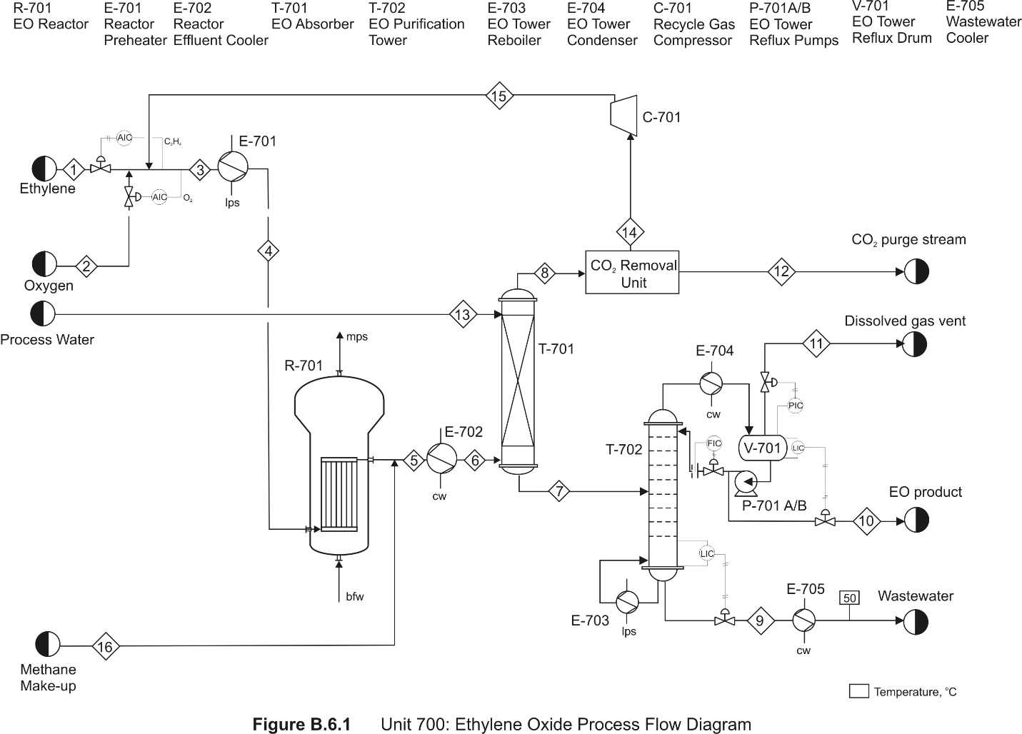

* Page 1314, Table B.6.1, has the following corrections that correspond to the new PFD in Figure B.6.1

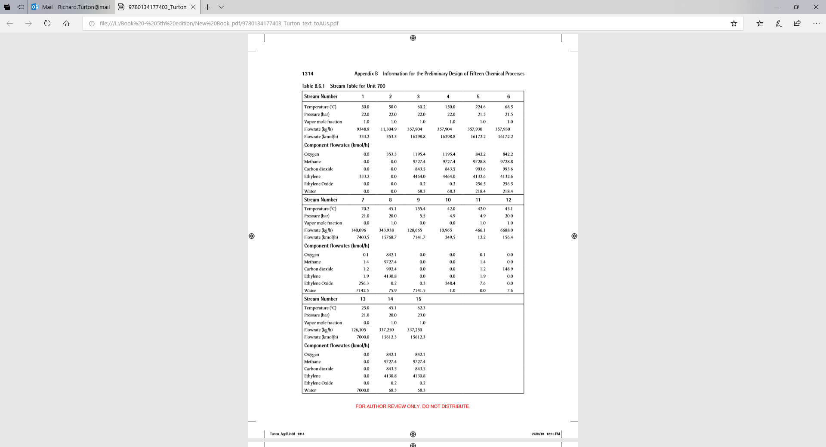

16

**210.0**

**22.4**

**0.0**

**0.0**

**0.0**

**0.0**

**0.0**

**1.4**

**1.4**

**1.0**

**21.5**

* Page 1344, Figure B.11.1 – Streams 6 and 7 are derived from a simulation that uses a component separator at the top of T-1201. In order to get the sharp separation of propane from the remaining hydrocarbons shown in the stream table, Table B.11.1, an additional tower is required.