Capcost 2017

Changes to the Program
Here is a list of the major changes to the program (from Capcost_2012 distributed with the 4th Edition)
- All utility costs have been updated in the User Options worksheet to correspond to those in Table 8.3 in the 5th edition.
- Utility Cost worksheets have been added that allow the user to easily estimate the costs of utilities as fuel and electricity prices change. The values shown in the worksheet correspond to the calculations and numbers reported in Chapter 8.
- A previous bug associated with calculating the cost of operating labor has been fixed
- The Equipment Summary worksheet has been updated to give both the purchased and bare module costs for the equipment as well as the equipment and bare module costs for the base conditions (MOC = CS and P = 1 bar) as shown below.

- A Lang factor calculation has been added and this can be used in the cost of manufacturing worksheet as an option, as shown below.
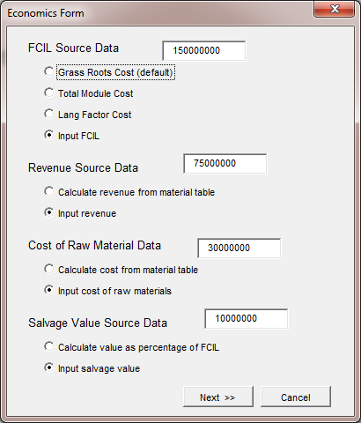

- In the Vessels and Towers Equipment input sheets, the Maximum Allowable Stress and Weld Efficiency can now be specified separately. This allows the user to change the MAS to correspond to the temperature at which the equipment operates – previously a default value for CS of 944 barg was used for all materials. See below:

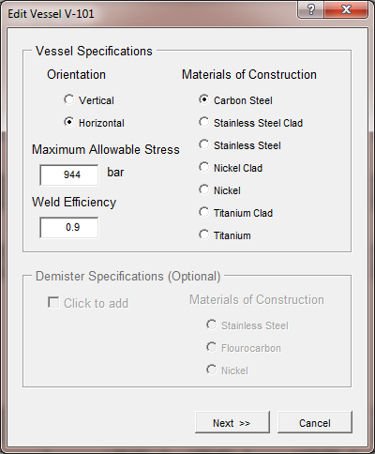

- The algorithm for determining the use of multiple vessels and towers when the specified size exceeds the maximum range has been simplified and is now consistent with other equipment in the program.

- A few other minor bugs regarding inconsistencies in the Data in Appendix A and the Equipment Cost Data worksheet have been fixed

